EXPERIMENT 8 – DFS (DEPTH FIRST SEARCH )

AIM
To develop a Python program to implement the Depth First Search (DFS) algorithm for graph traversal.

OBJECTIVE
To demonstrate how the Depth First Search (DFS) algorithm traverses all vertices of a graph by exploring each branch as deeply as possible before backtracking.

ALGORITHM
- Start.
- Create the graph, choose the starting vertex, and mark it as visited.
- Visit the current vertex and recursively visit each unvisited adjacent vertex.
- Continue the process until all reachable vertices are visited using backtracking.
- Display the DFS traversal order and
- Stop.

SAMPLE CODE
graph = {
'A': ['B', 'C'],
'B': ['D', 'E'],
'C': ['F'],
'D': [],
'E': ['F'],
'F': []
}

visited = set()

def dfs(node):
if node not in visited:
print(node, end=" ")
visited.add(node)

for neighbour in graph[node]:
dfs(neighbour)

print("DFS Traversal:")
dfs('A')

FLOW CHART



OUTPUT
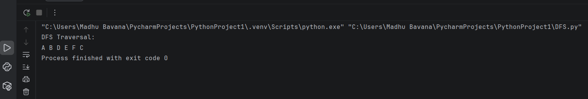

RESULT
The Python program was executed successfully. The Depth First Search (DFS) algorithm traversed the graph by exploring each branch completely before backtracking and successfully visited all the vertices.

